|  |  |  |
| --- | --- | --- |
| |  |  | | --- | --- | | |  | | --- | | *Human Perspectives ATAR Units 3 & 4* | | |

Worksheet 7.2 Specific resistance to infection

Answers

Using Chapter 7 of *Human Perspectives ATAR Units 3 & 4*, complete the following activities.

**1** Define the term ‘pathogen’.

*Answer:* A disease-causing organism

**2** What is the difference between lymphocytes and macrophages?

*Answer:* A macrophage is a specialised monocyte that consumes cell debris and pathogens through phagocytosis.

A lymphocyte is a specialised white blood cell that is responsible for the specific immune response.

**3** Where are B and T lymphocytes matured before being released into the bloodstream?

**B cells:**

*Answer:* in the bone marrow

**T cells:**

*Answer:* in the thymus

**4** Define the term ‘antigen’. What is the difference between a self and non-self antigen?

*Answer:* An antigen is any substance capable of causing a specific immune response. Self antigens are produced by your own body and do not cause an immune response. Non-self antigens are foreign compounds and do trigger an immune response.

**5** Define the term ‘antibody’. To what group of proteins do antibodies belong?

*Answer:* An antibody is a Y-shaped specialised protein that is produced by plasma cells in response to a non-self antigen. They belong to a group of proteins called immunoglobulins.

**6** Draw a diagram showing the main steps involved in the humoral response to disease.

*Answer:* Refer to Figure 7.20 in the student book.

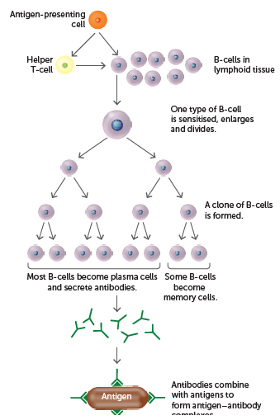

**7** Draw a graph showing the change over time in the concentration of an antibody after an initial exposure to an antigen followed by a subsequent exposure to the same antigen four weeks later. Clearly label the graph, including any lines drawn.

*Answer:* Refer to Figure 7.21 in the student book.

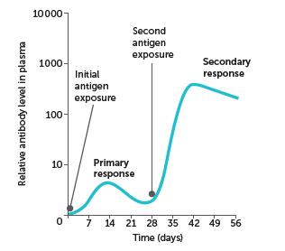

**8** Antigen–antibody complexes form once an antibody makes contact with an antigen for which it is specific. List some responses that occur once antigen–antibody complexes have been formed.

*Answer:*

• Inactivate foreign enzymes or toxins by combining with them or inhibiting their reaction with other cells or compounds

• Bind to the surfaces of viruses and prevent them entering cells

• Coat bacteria so they are more easily consumed by phagocytes

• Cause particles to clump together (agglutination)

• Dissolve organisms

• React with soluble substances to make them insoluble and more easily consumed by phagocytosis

**9** Draw a diagram showing the main steps involved in the cell-mediated response to infection.

*Answer:* Refer to Figure 7.25 in the student book.

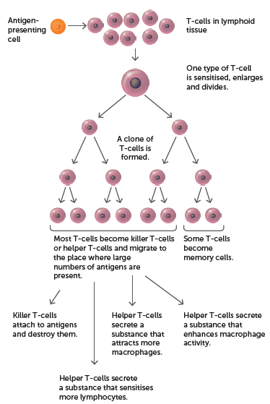

**10** Describe any differences between killer T cells and helper T cells.

*Answer:* Killer T-cells (or Cytotoxic T-cells) migrate to the site of infection and attach to the invading cells, secreting a chemical that destroys the antigen and goes in search for more antigens

Helper T-cells bind to the antigen on antigen-presenting cells and stimulate the secretion of cytokines. Cytokines attach more lymphocytes to the infection site to become sensitised and activated. Cytokines attract macrophages to the place of infection so the macrophages can destroy the antigens by phagocytosis, cytokines intensify the phagocytotic action of macrophages and promote the action of killer T-cells.

**11** State the differences between:

**a** passive and active immunity

*Answer:* Passive immunity is when a person receives antibodies produced by someone else. Active immunity results when the body is exposed to the foreign antigen and manufactures antibodies in response to that antigen.

**b** natural and artificial immunity.

*Answer:* Natural immunity occurs without any human intervention, whereas artificial immunity results from giving people an antibody or antigen.

**12 a** What is the purpose of vaccination?

*Answer:* Vaccination is the artificial introduction of antigens of pathogenic organisms so the ability to produce the appropriate antibodies is acquired without the person having to suffer the disease.

**b** Is there a difference between immunisation and vaccination? Explain.

*Answer:* Immunisation means programming the immune systems so that the body can respond rapidly to infecting micro-organisms and can occur naturally or artificially. Vaccination is the artificial introduction of antigens of pathogenic organisms.

**13** Complete the following table.

*Answer:*

|  |  |  |
| --- | --- | --- |
| **Type of vaccine** | **Description of vaccine preparation** | **Used for immunisation against** |
| Live attenuated vaccine | Micro-organisms of reduced virulence (ability to produce disease symptoms) | Polio, tuberculosis, rubella, measles, mumps and yellow fever |
| Inactivated vaccine | Contain dead micro-organisms | Cholera, typhoid, whooping cough |
| Toxoids vaccine | Inactivated toxins from bacteria | Diptheria and tetanus |
| Sub-unit vaccine | A fragment of the micro-organism | Human papilloma virus and hepatitis B |

**14** Draw a graph showing the change over time in the concentration of an antibody following injection of a vaccine, and following a second injection four weeks later. Clearly label the graph, including any lines drawn. Are there similarities between this graph and the graph you drew in your answer to Question 7?

*Answer:* Refer to Figure 7.21 in the student book.

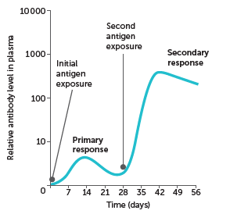

There should be no differences between this graph and the one prepared for Question 7.

**15** Draw a graph showing the change over time in the concentration of an antibody following the injection of a vaccine, and then exposure to a different pathogen four weeks later. Clearly label the graph, including any lines drawn. Explain any differences between this graph and the graph you drew in your answer to Question 14.

*Answer:* The exposure to a different pathogen should result in another primary response; the antibody levels should not rise higher or faster than what is seen after the vaccination.

